**Creating your Terraform infrastructure:**

1. Download MSI installer
2. Go to Microsoft

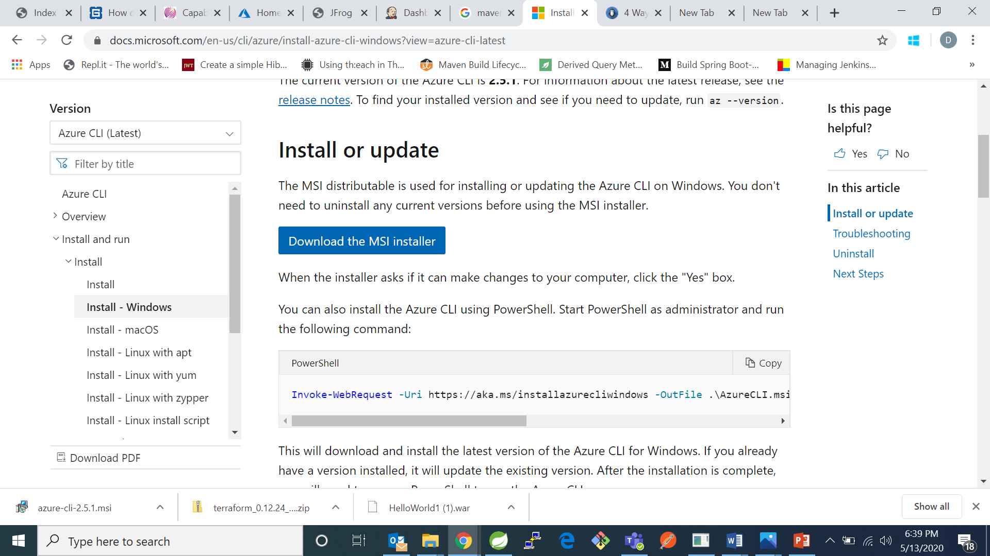

1. Go to downloads and click on the msi installer

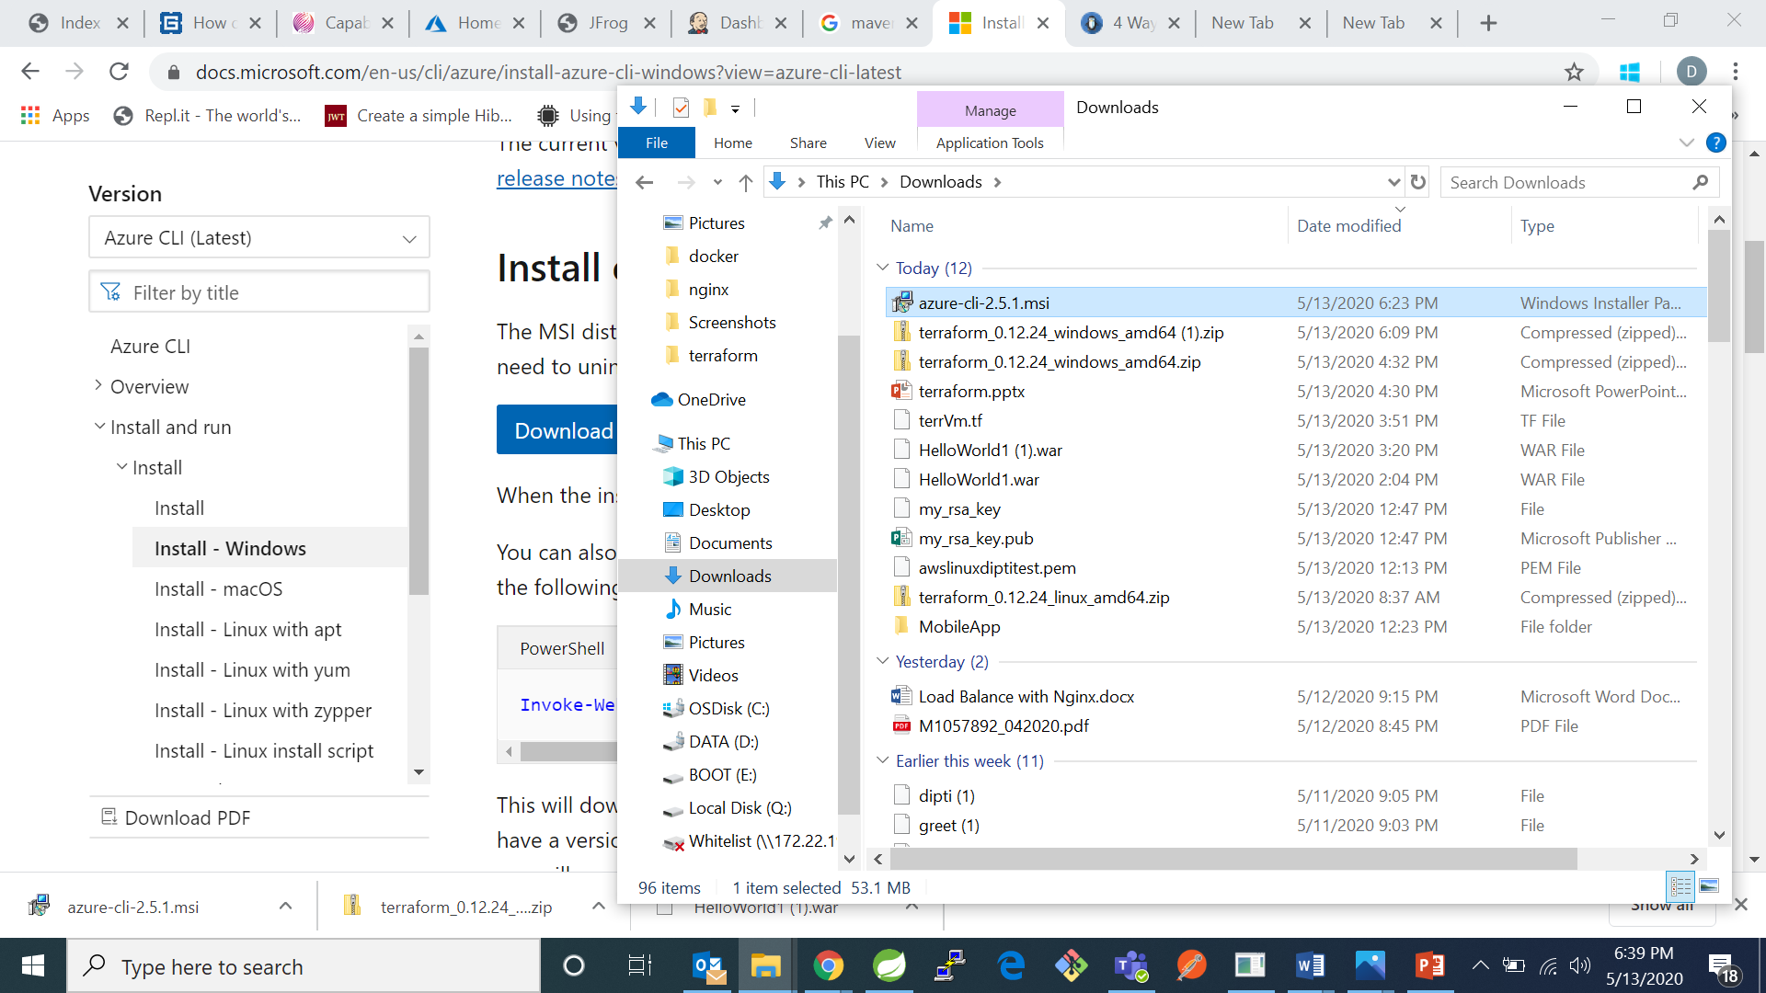

1. Click on install and then finish

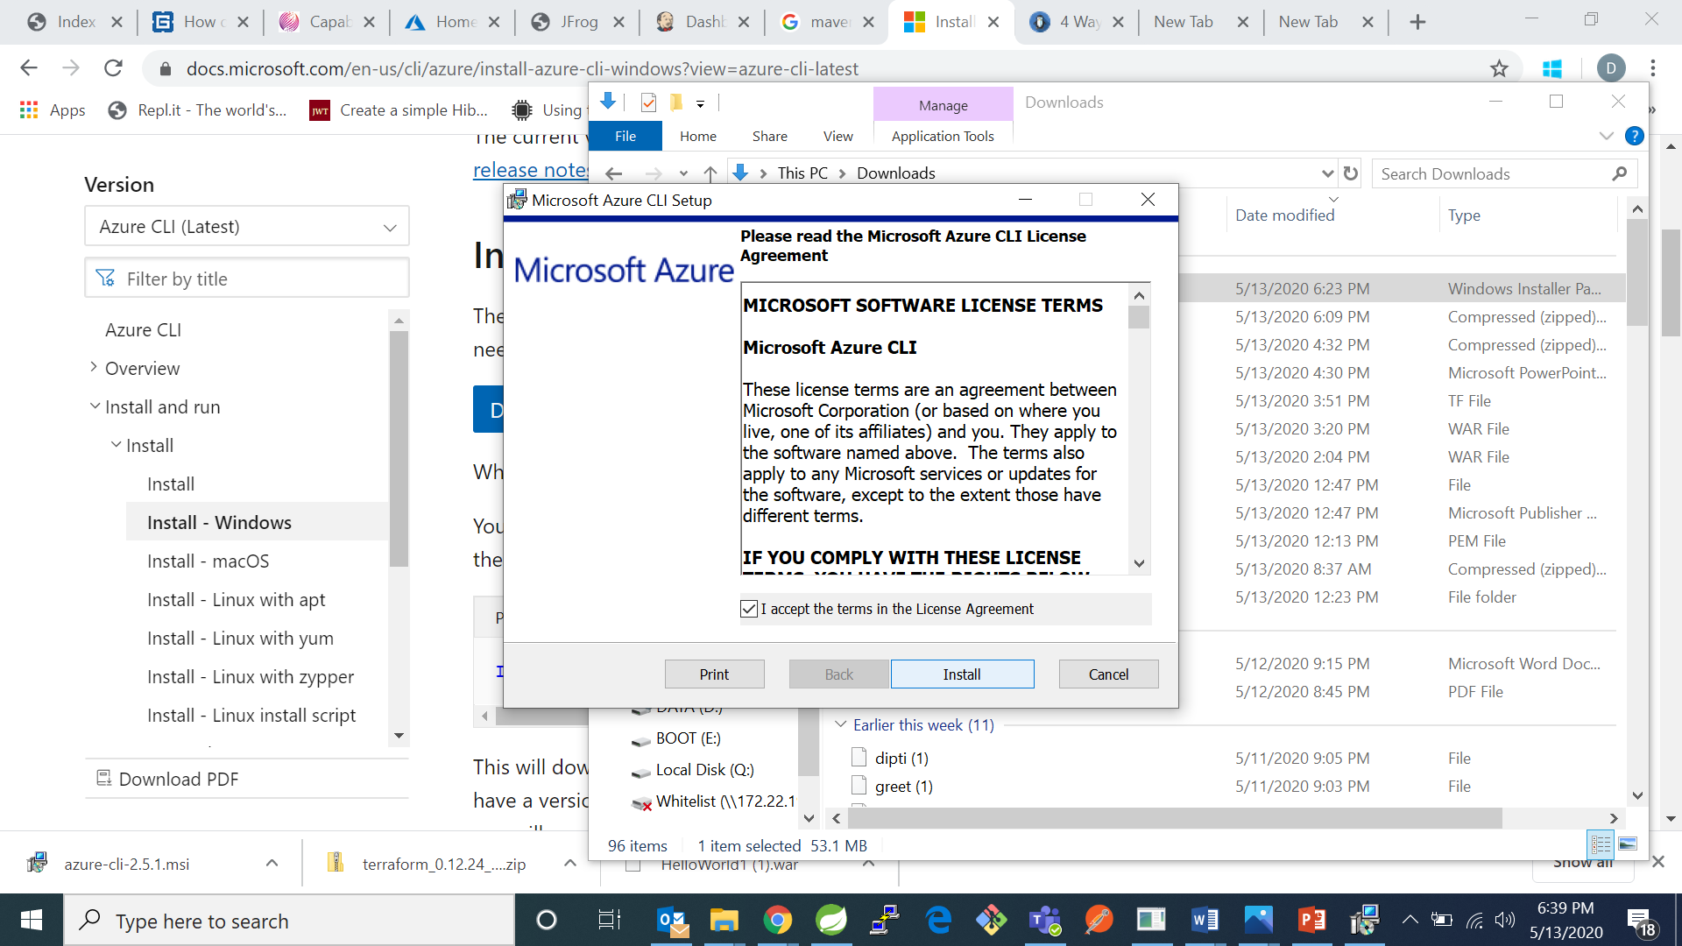 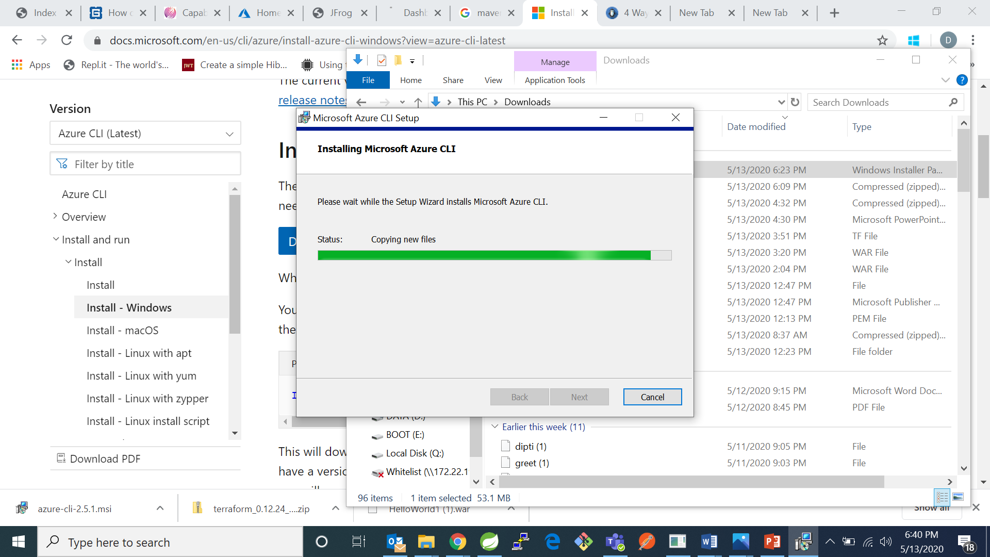

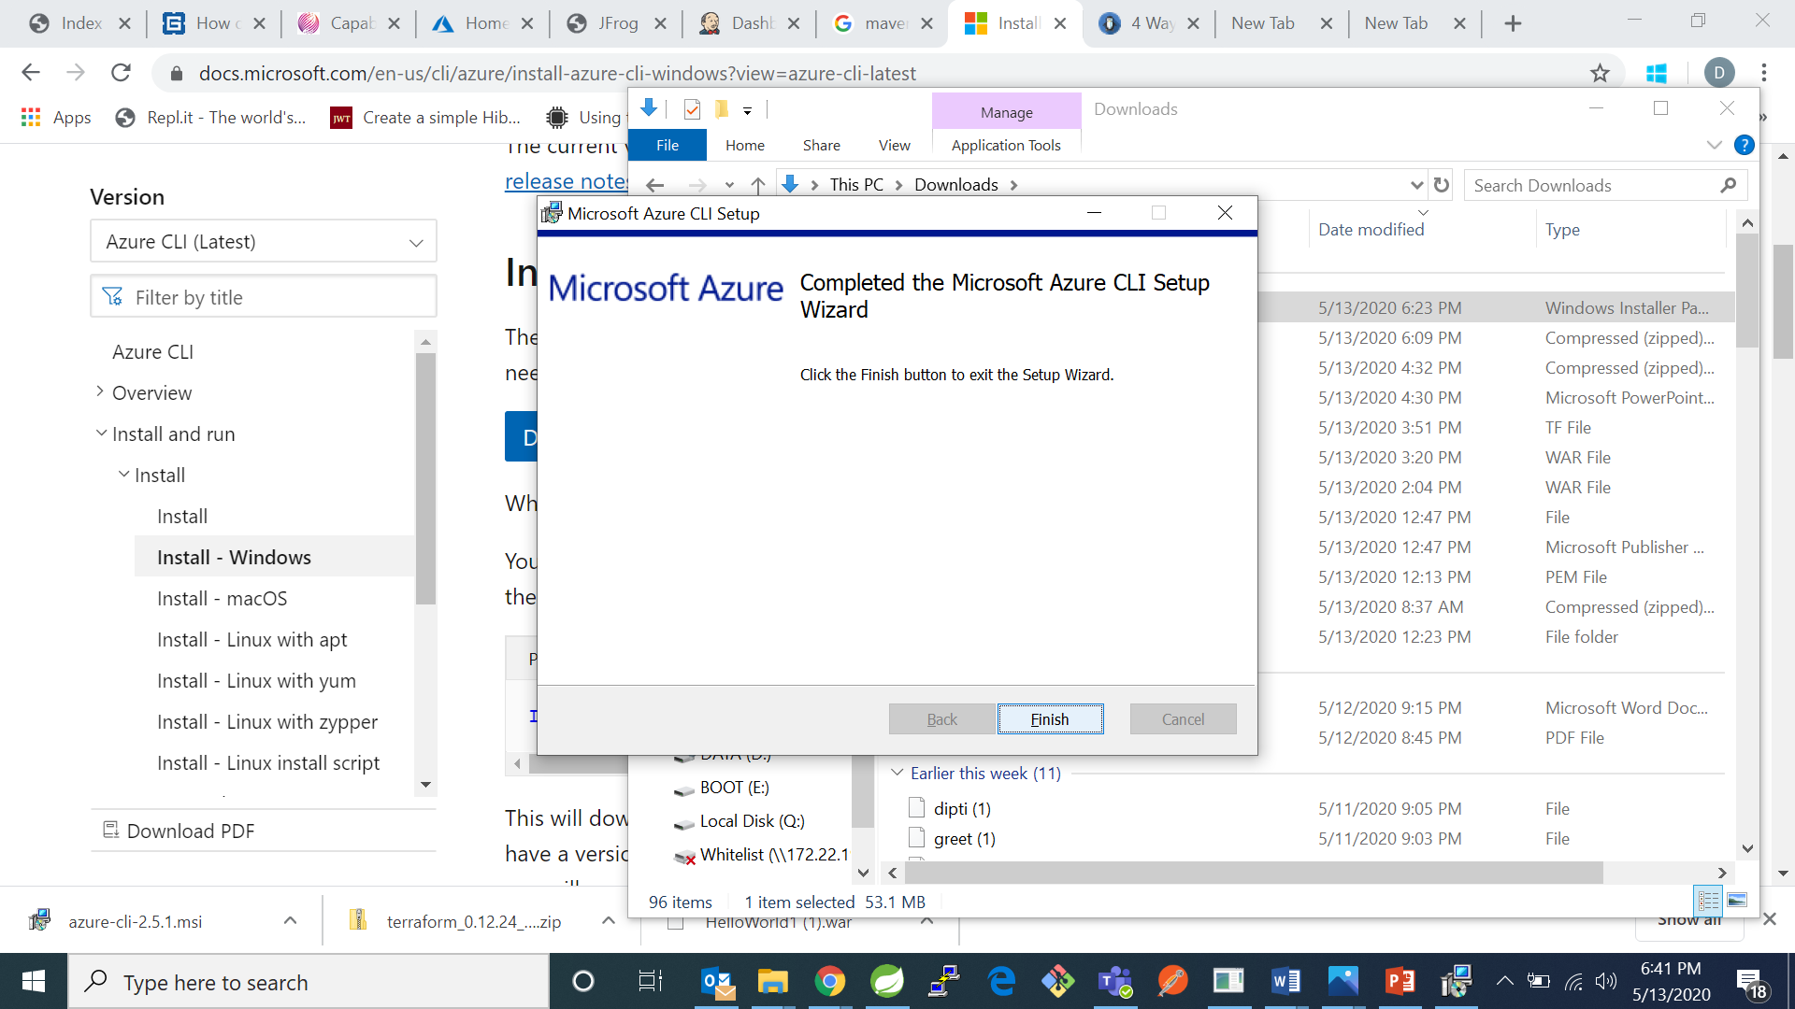

Then

1. Creating a basic resource group:
2. Go to cmd and type command az login

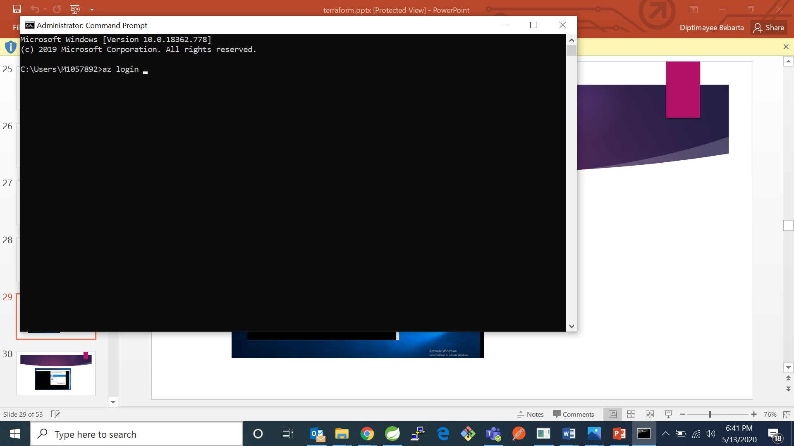

1. It will take to browser to login to your microsft azure account and login.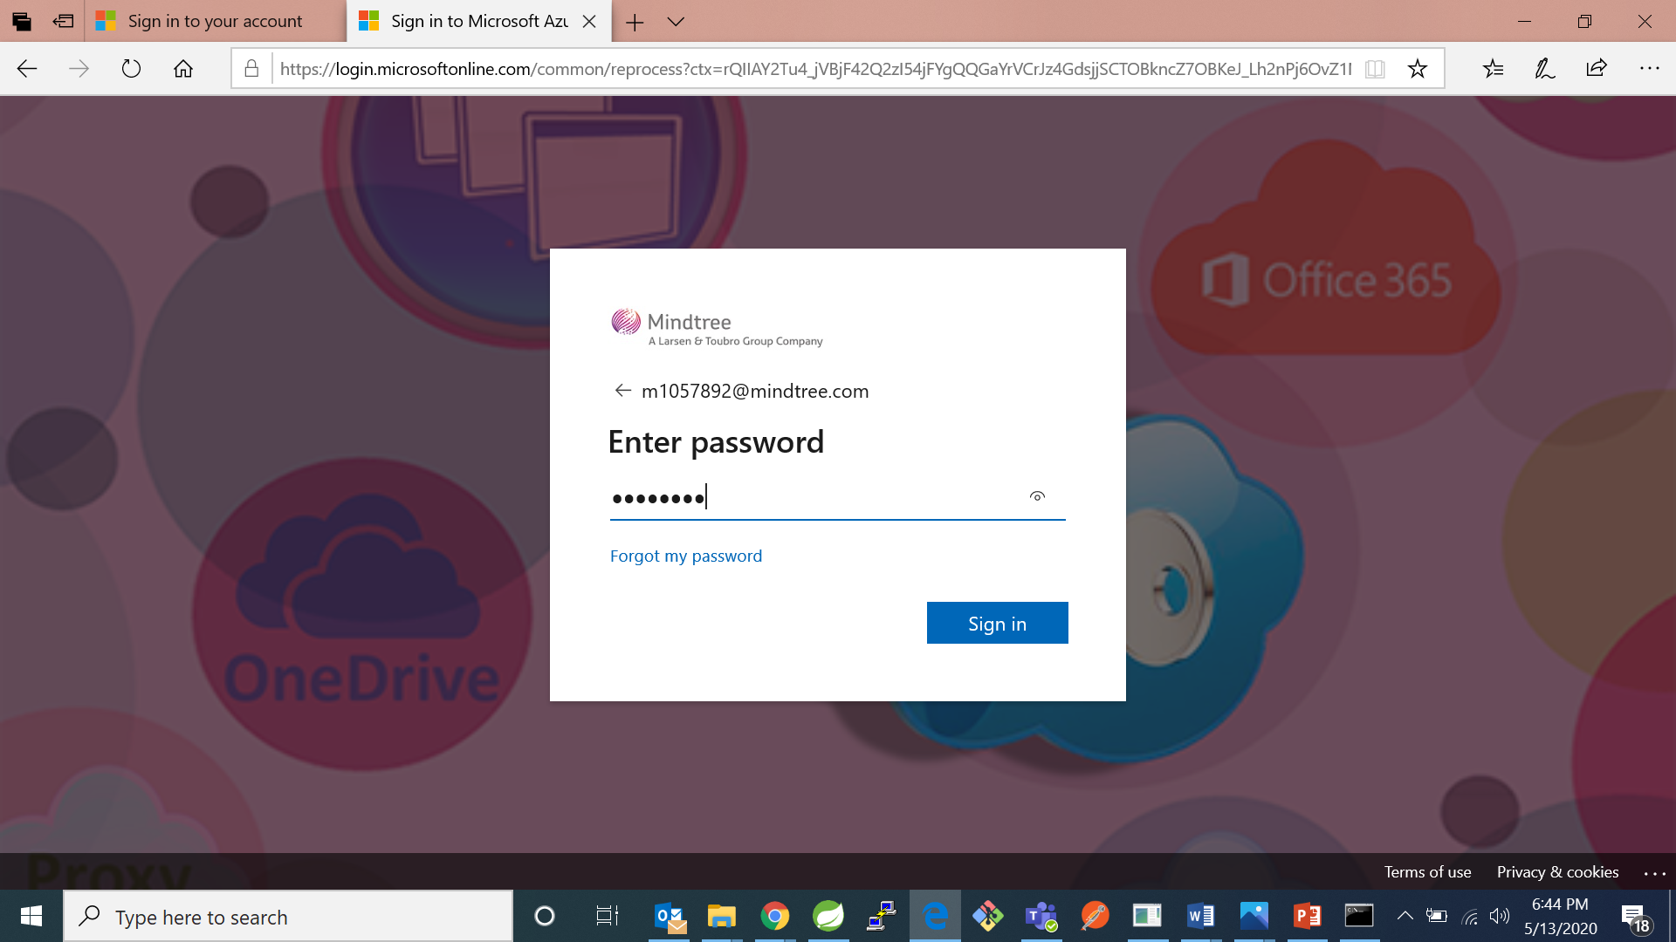
2. It will show a welcome message

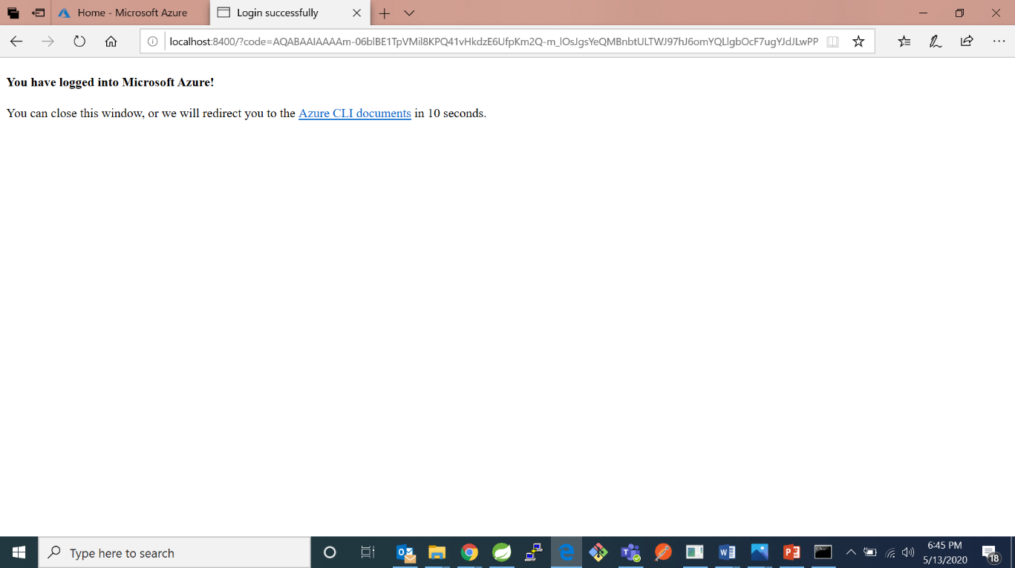

1. Now go back to cmd you can information regarding your session. 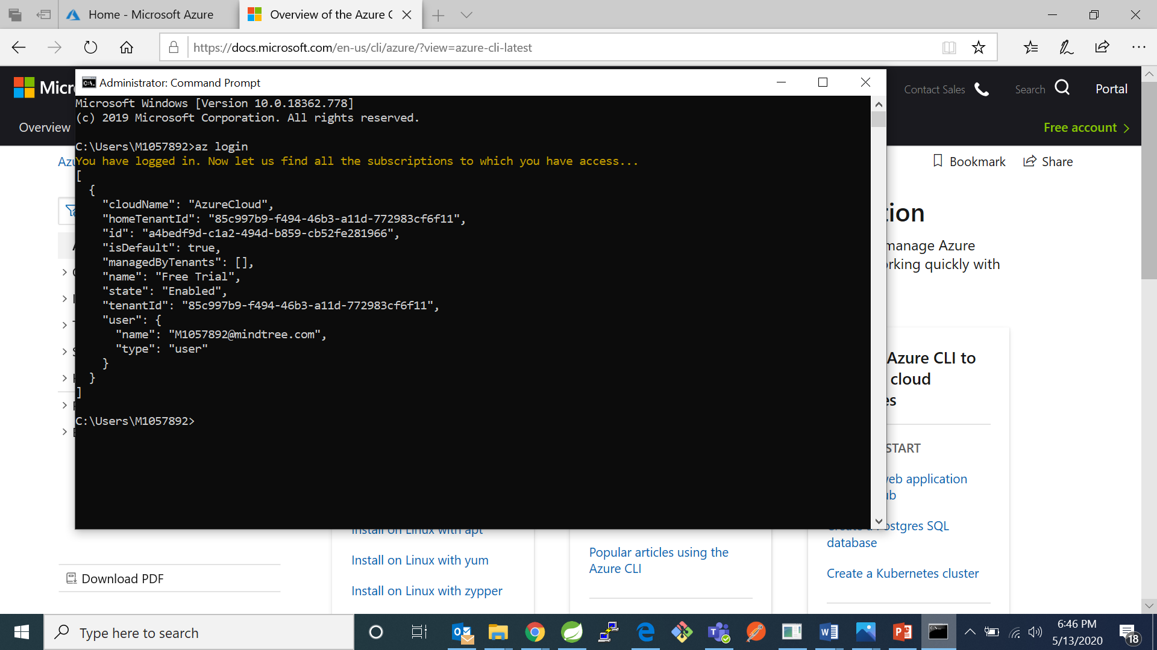
2. Go to VS Code and create a file named terraform .tf. In VS Code it will through a pop at down.

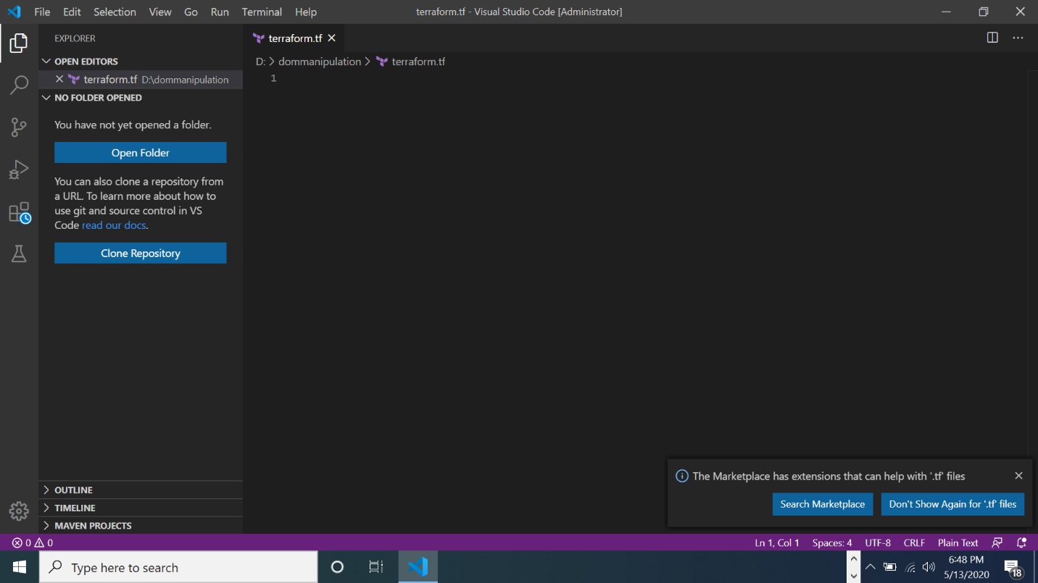

1. Click on that pop up. It will take you to install terraform for VS Code and click on install.

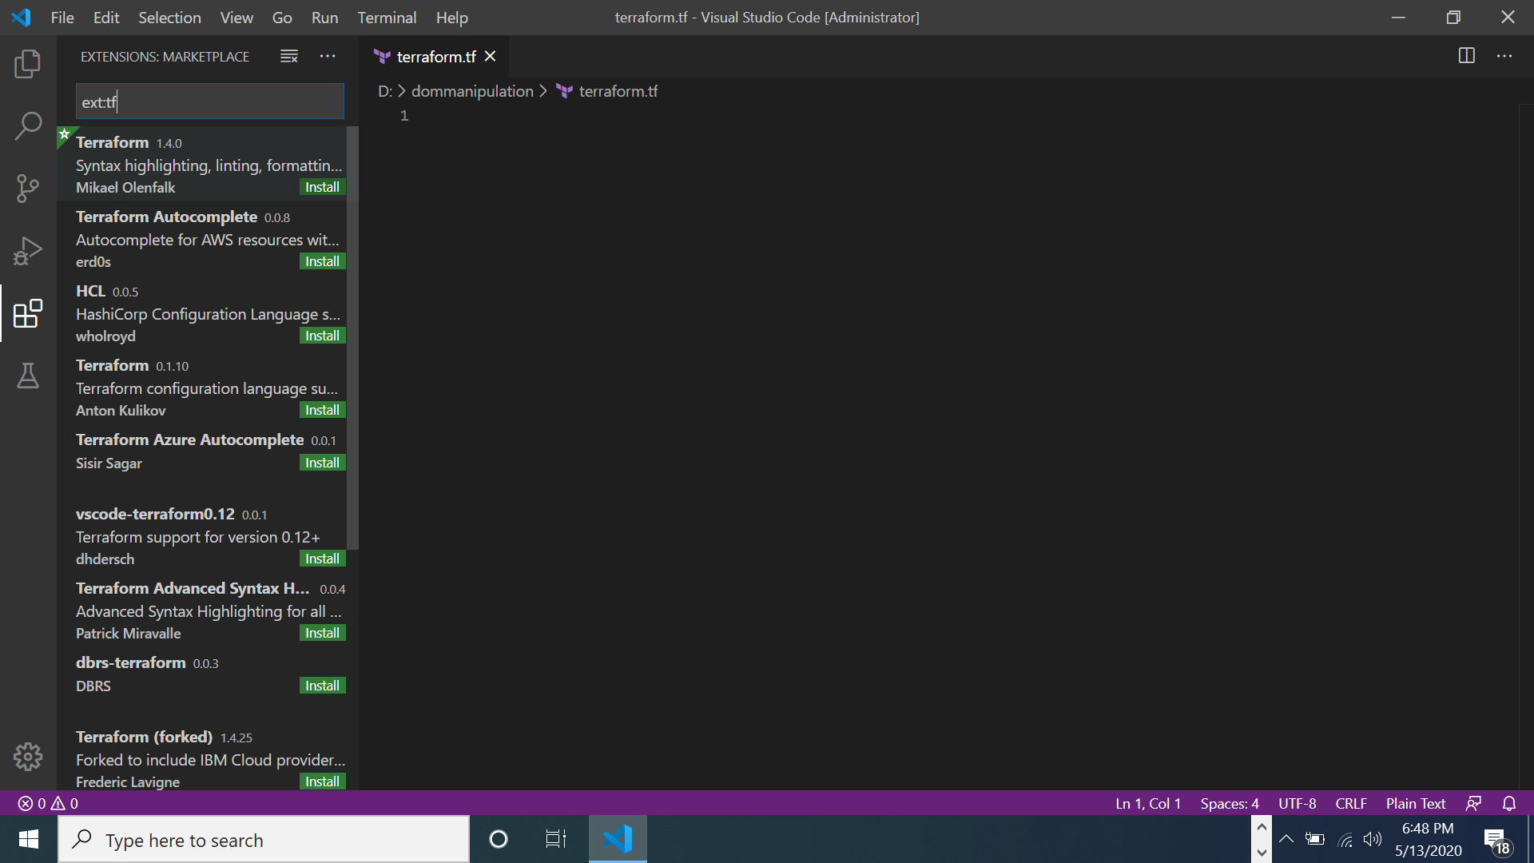

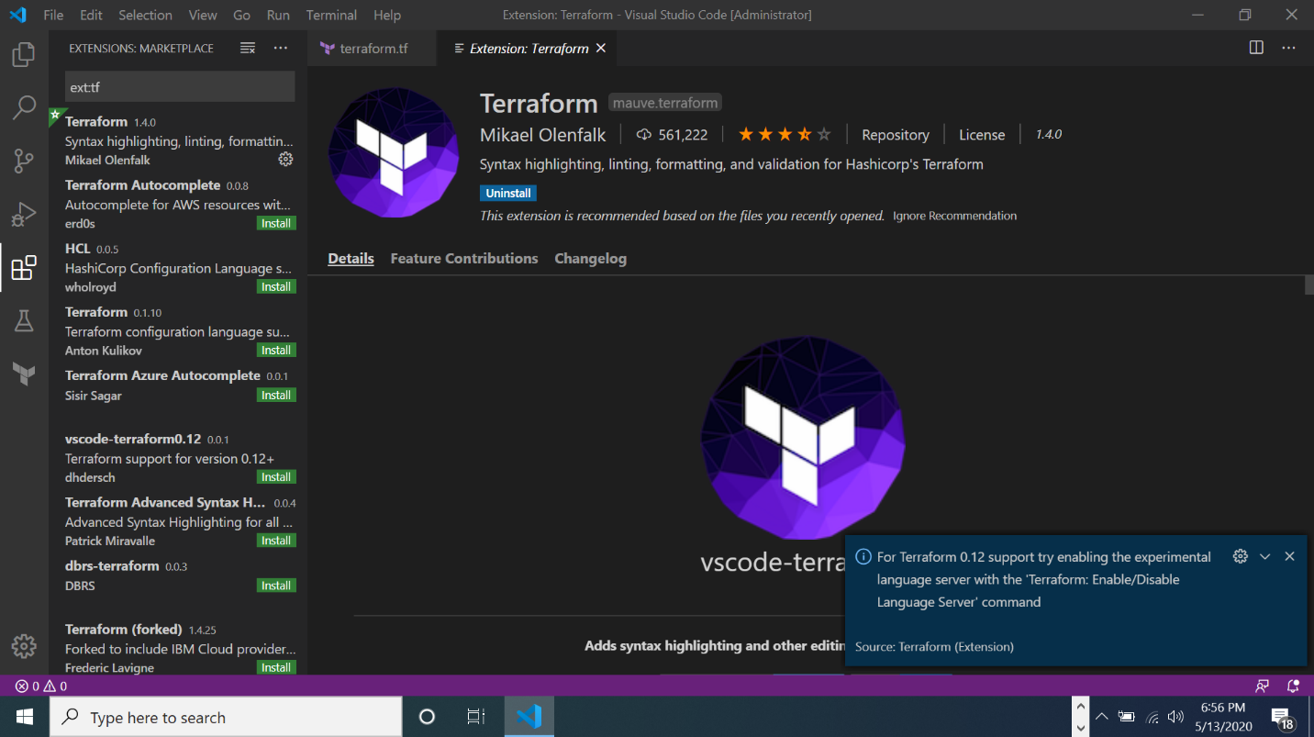

1. Write down the following code in it and save it

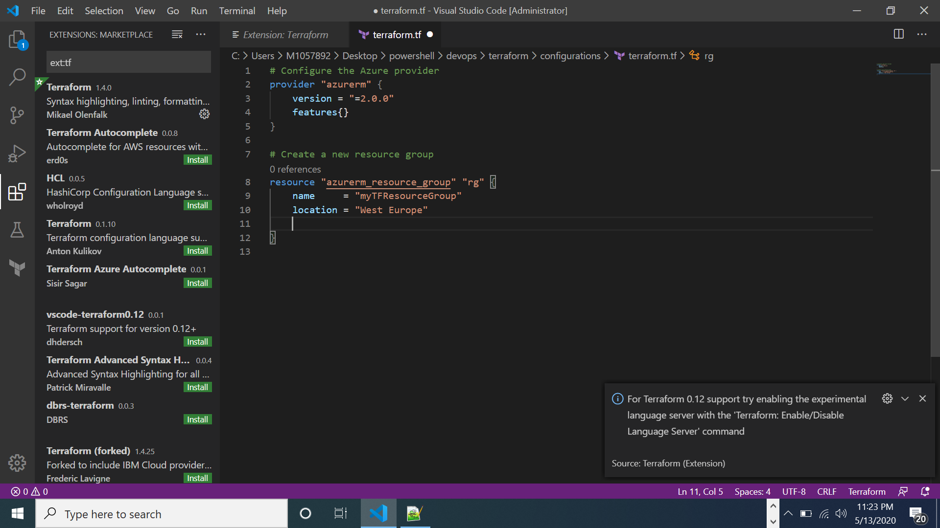

1. Now go to cmd and run command “terraform init”- command will automatically download and install any provider binaries required by the providers specified in the configuration.

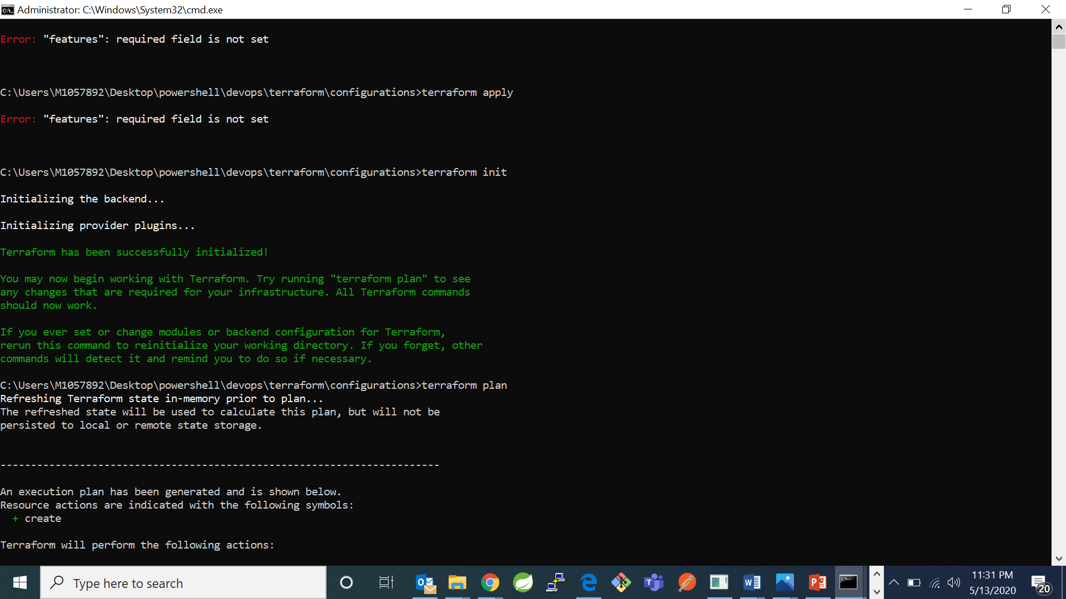

1. Now type command “terraform plan” -specifies what actions Terraform will take to achieve the desired state defined in the configuration, and the order in which the actions occur

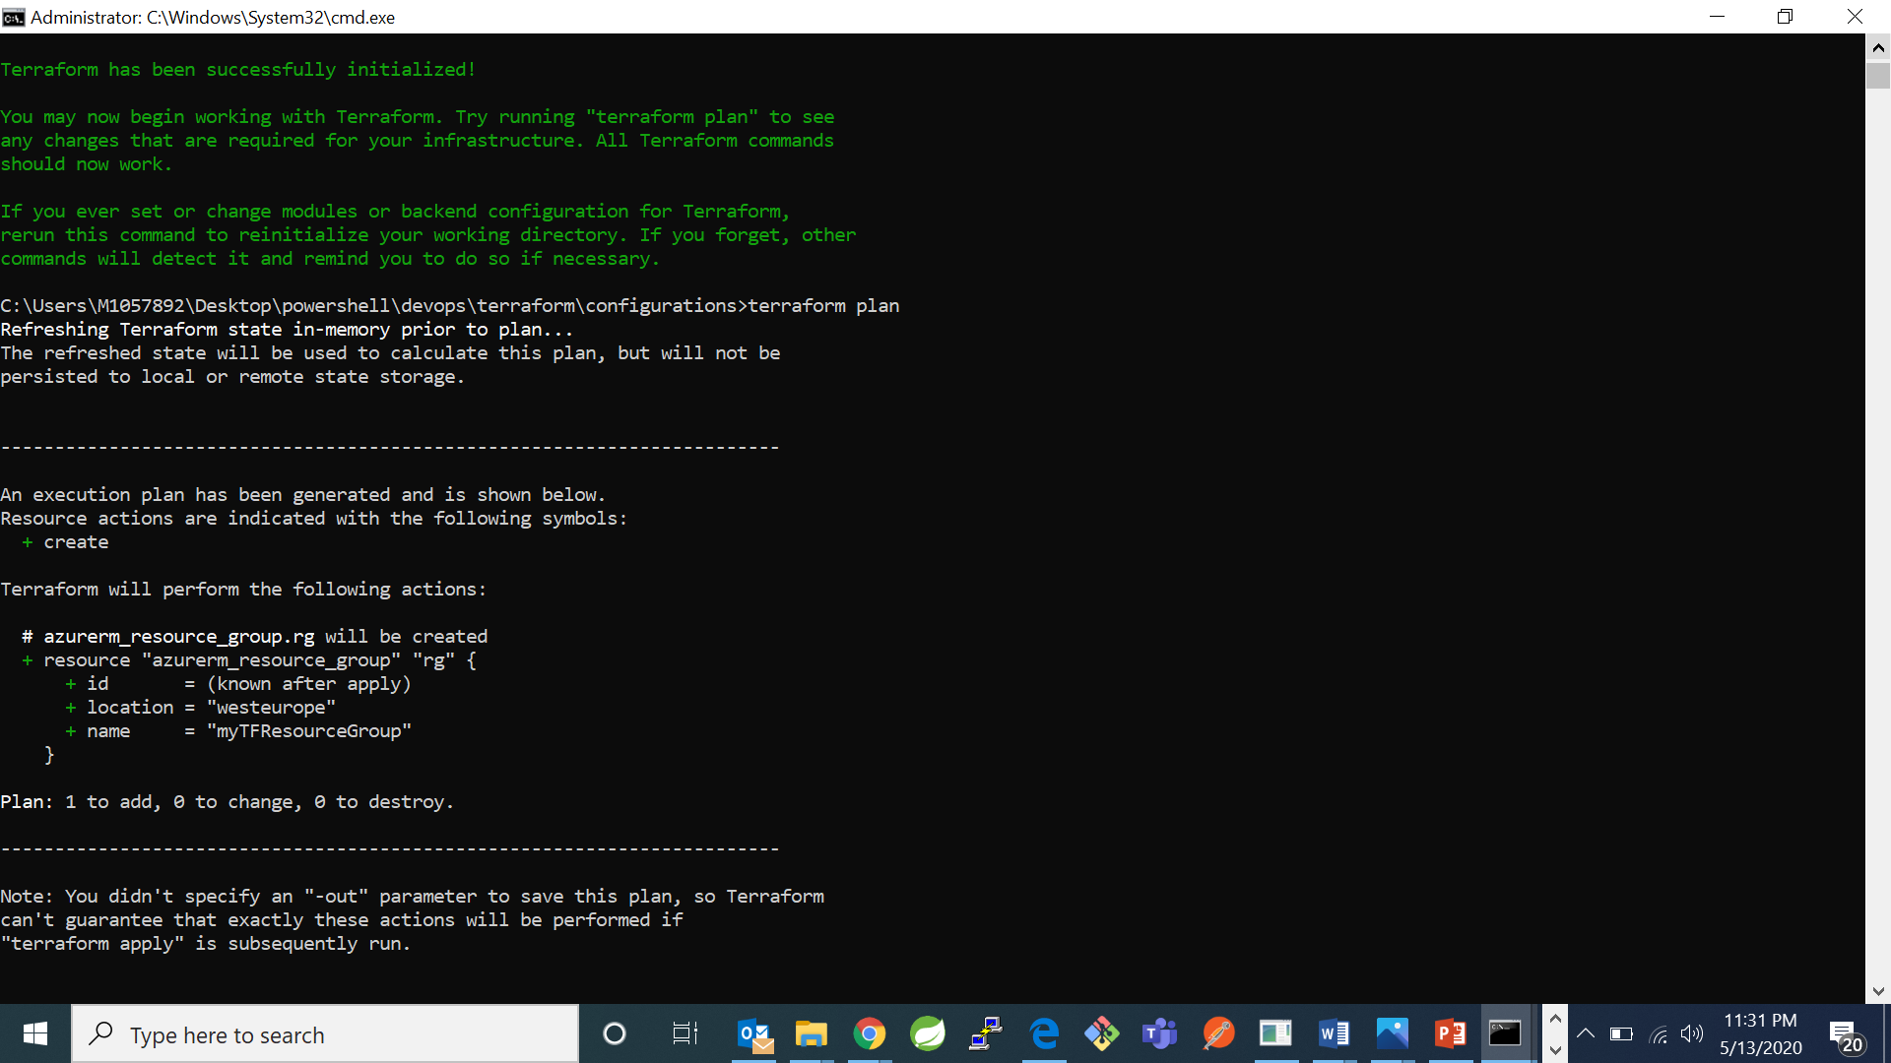

1. Now type command “terraform apply”- it will apply the changes to the configurations.

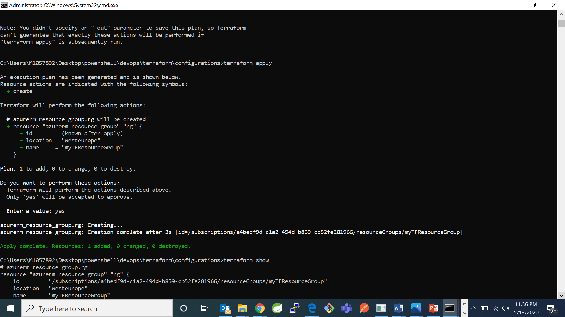

1. Now you can check the configuration made by you in the command line by typing the command “terraform show”

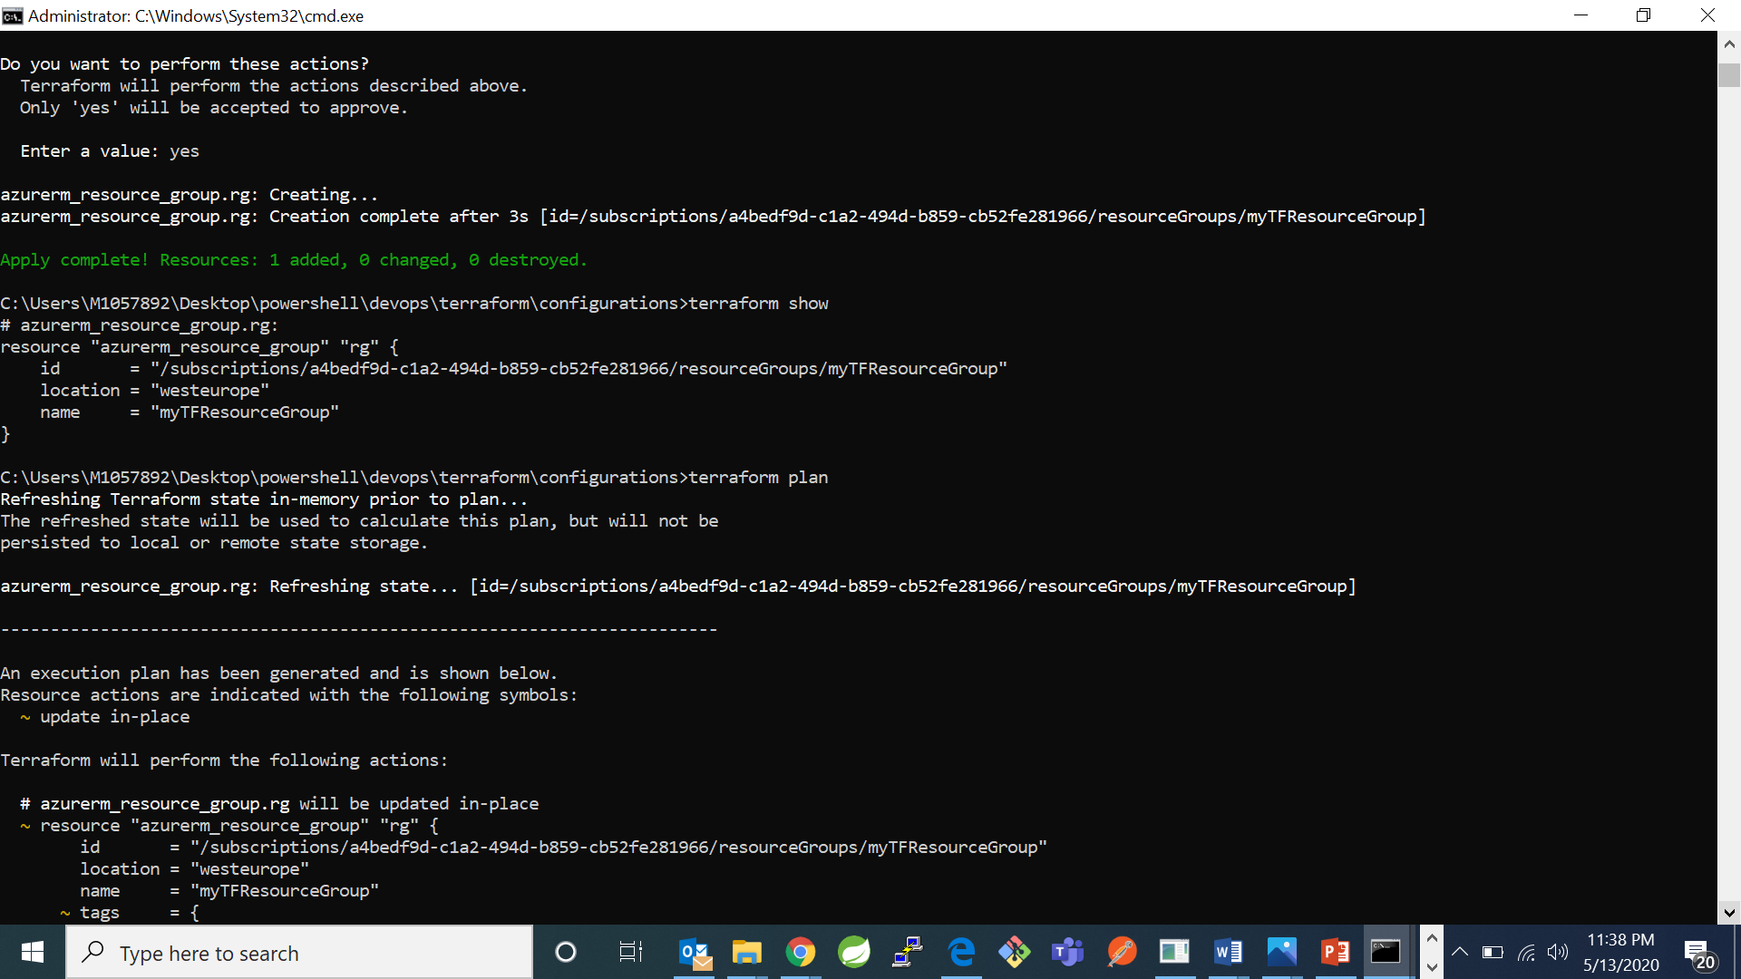

1. Now try making some changes in the configuration file. In my earlier code I added tag metadata in resource group

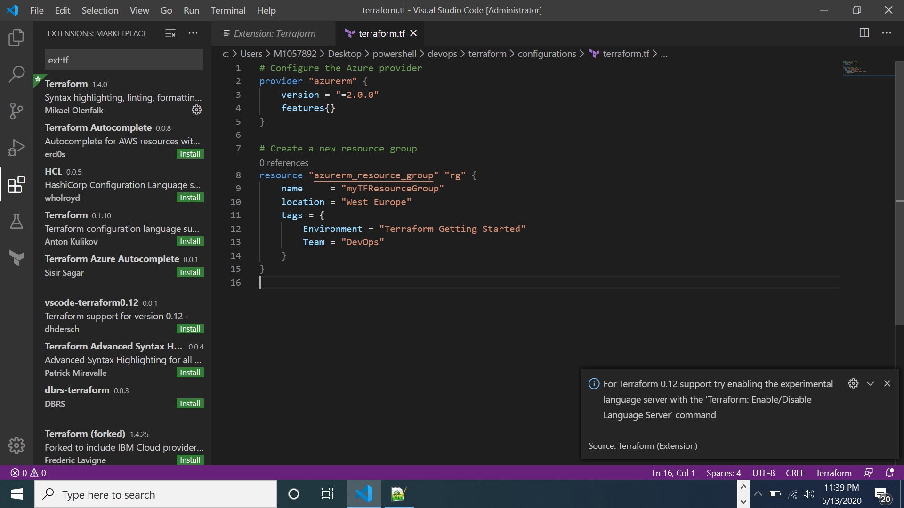

1. Now type command “terraform plan”

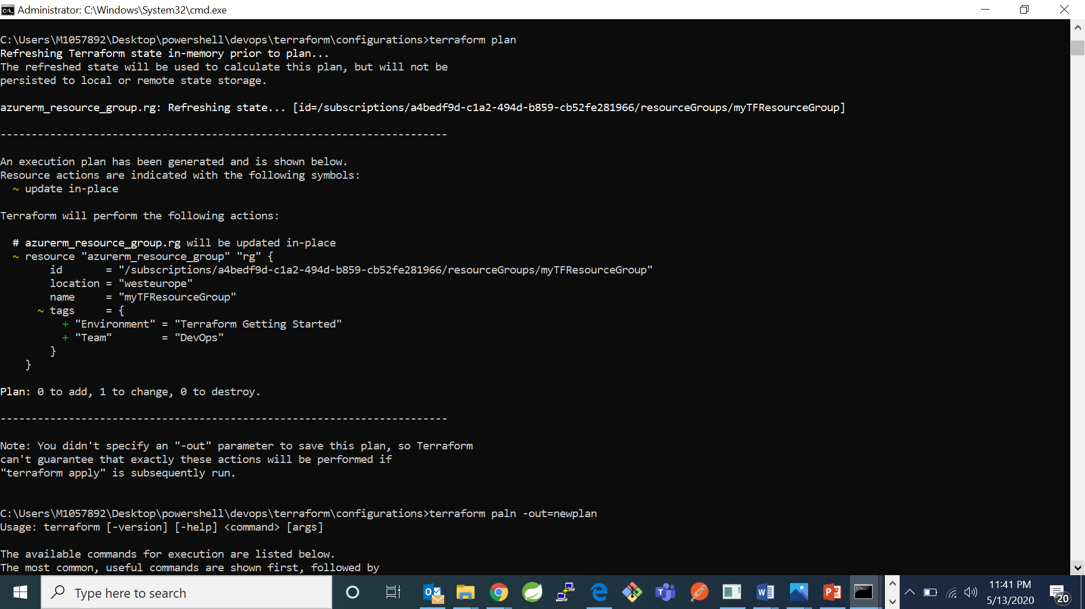

Whatever lines are indicated with the symbol ~ shows that , that group is updated and the second ~ shows the changes made and + shows those tags are added.

1. Now type command “terraform paln –out=newplan” –The -out argument tells Terraform to save the plan in a file named newplan in the current directory.

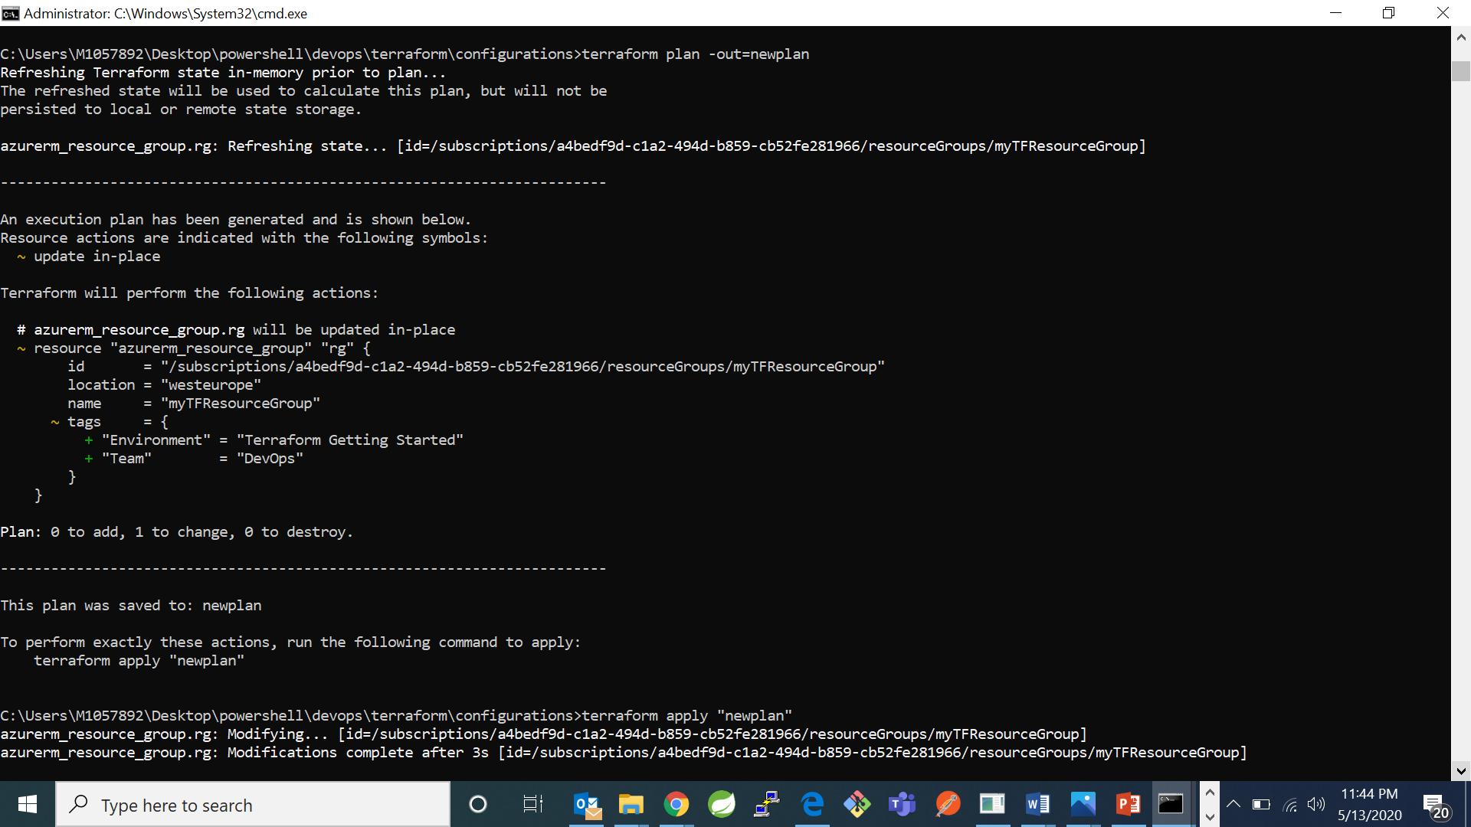

1. Now run the command “terraform apply “newplan” “ – it will apply changes to your configuration in infrastructure. 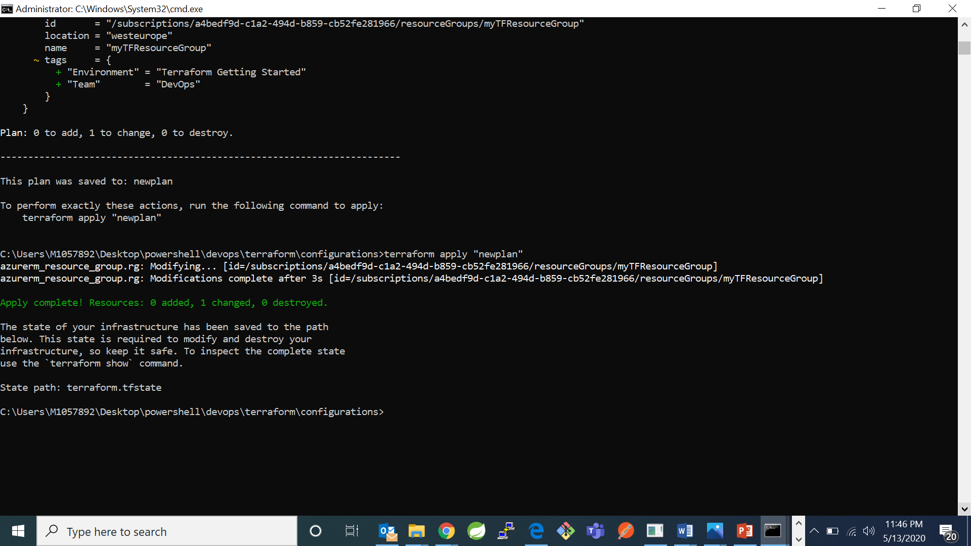
2. Now type command “terraform show “ to see your configurations

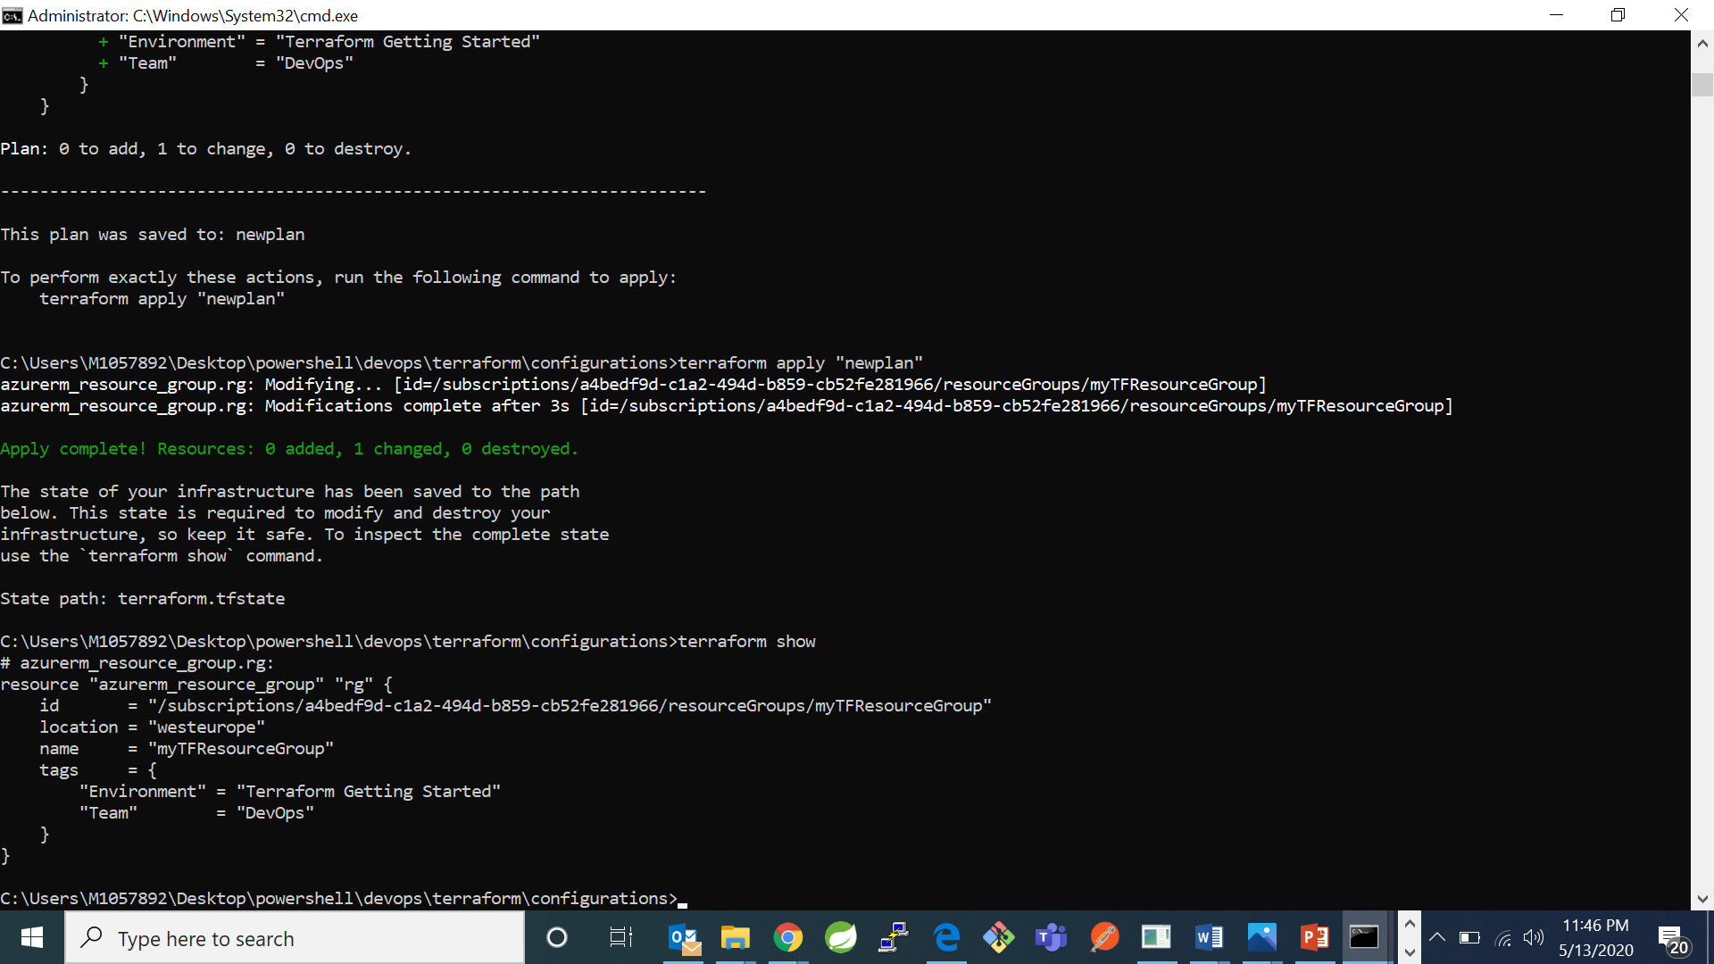

1. Now go to your azure portal in that go to resources group and check for your resource group is created or not

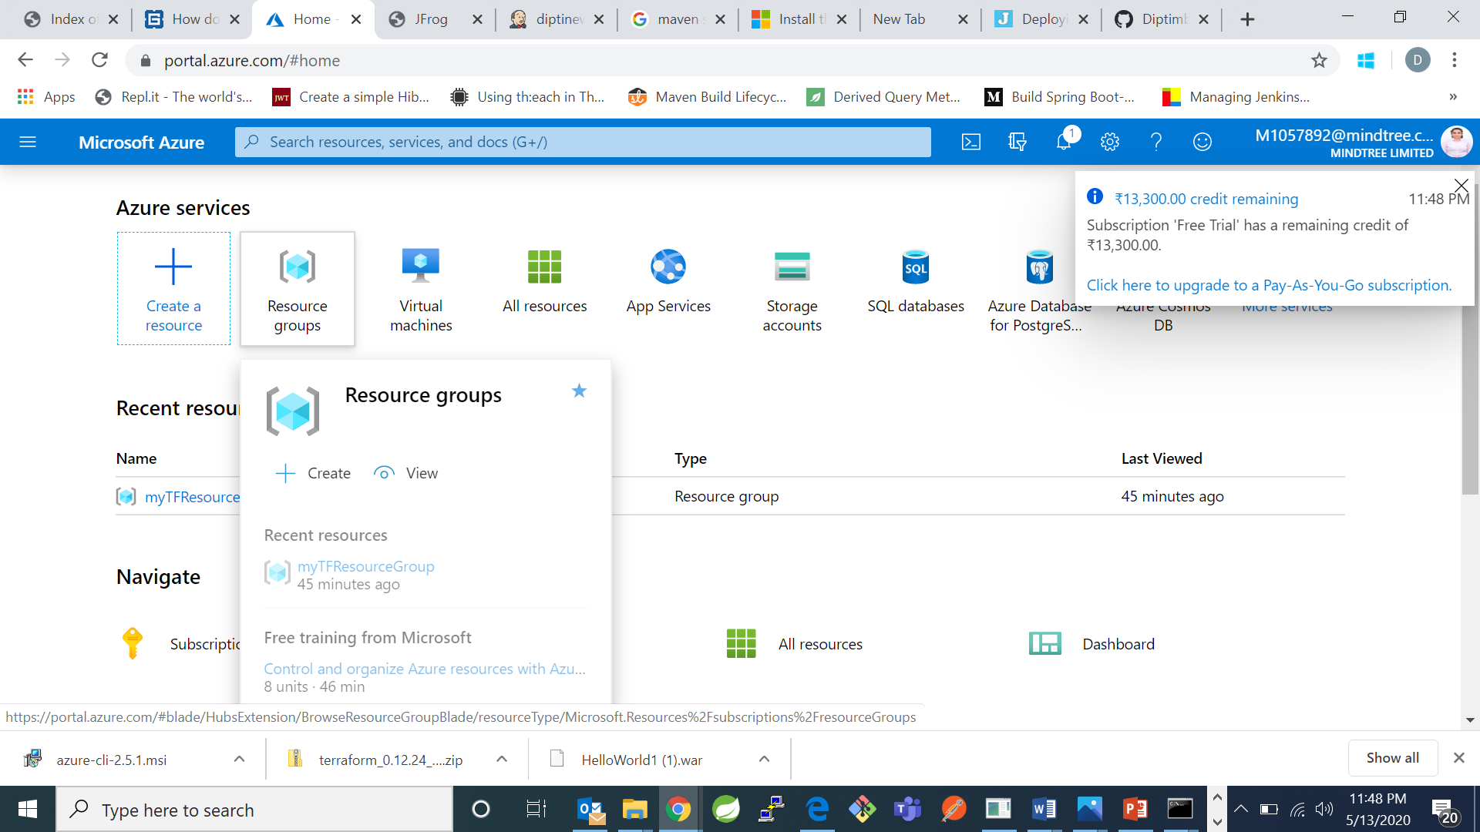

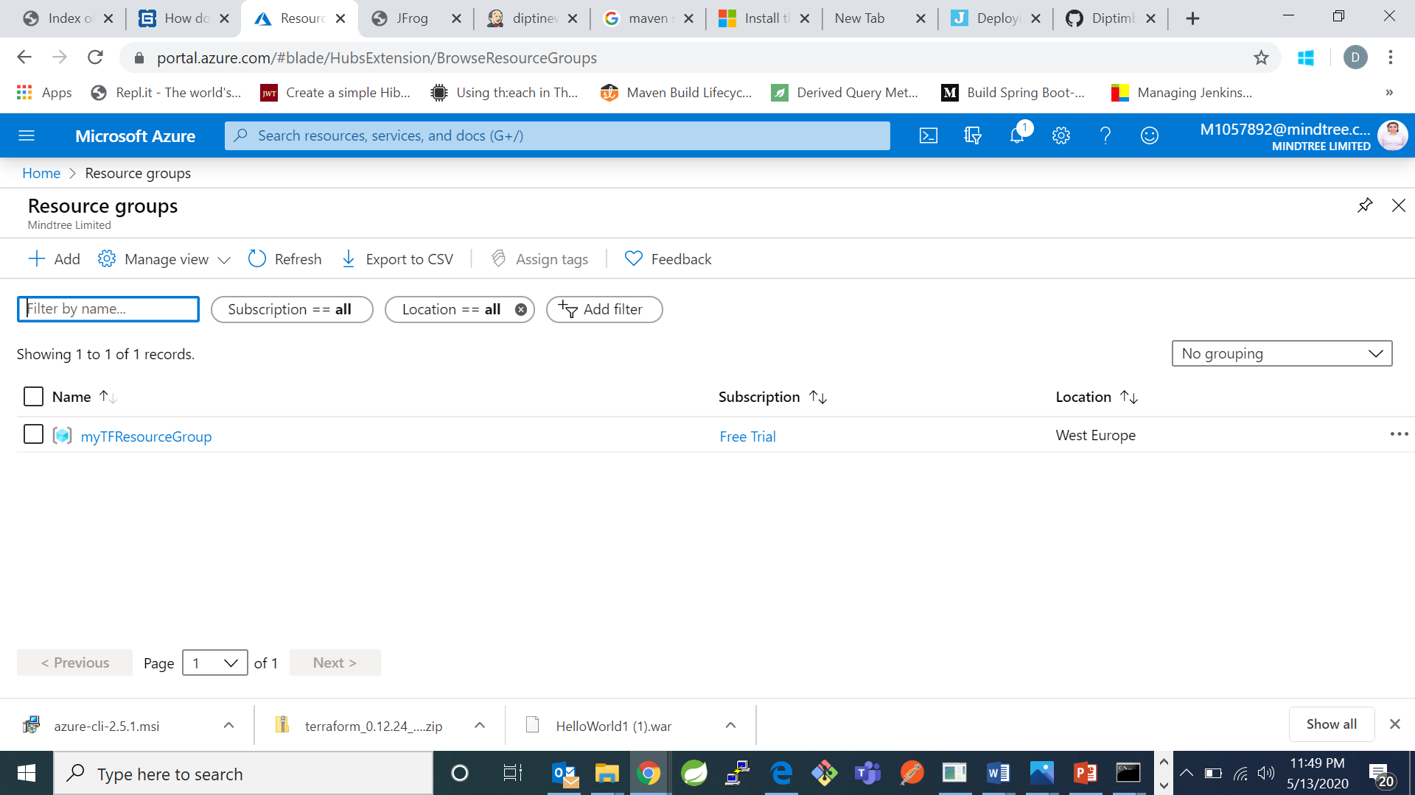

My resource group was successfully created.

**FOR LINUX:**

1. For installation of msi:
2. Type command: “sudo apt-get update”

“sudo apt-get install ca-certificates curl apt-transport-https lsb-release gnupg” – to get all packages needed for installation process

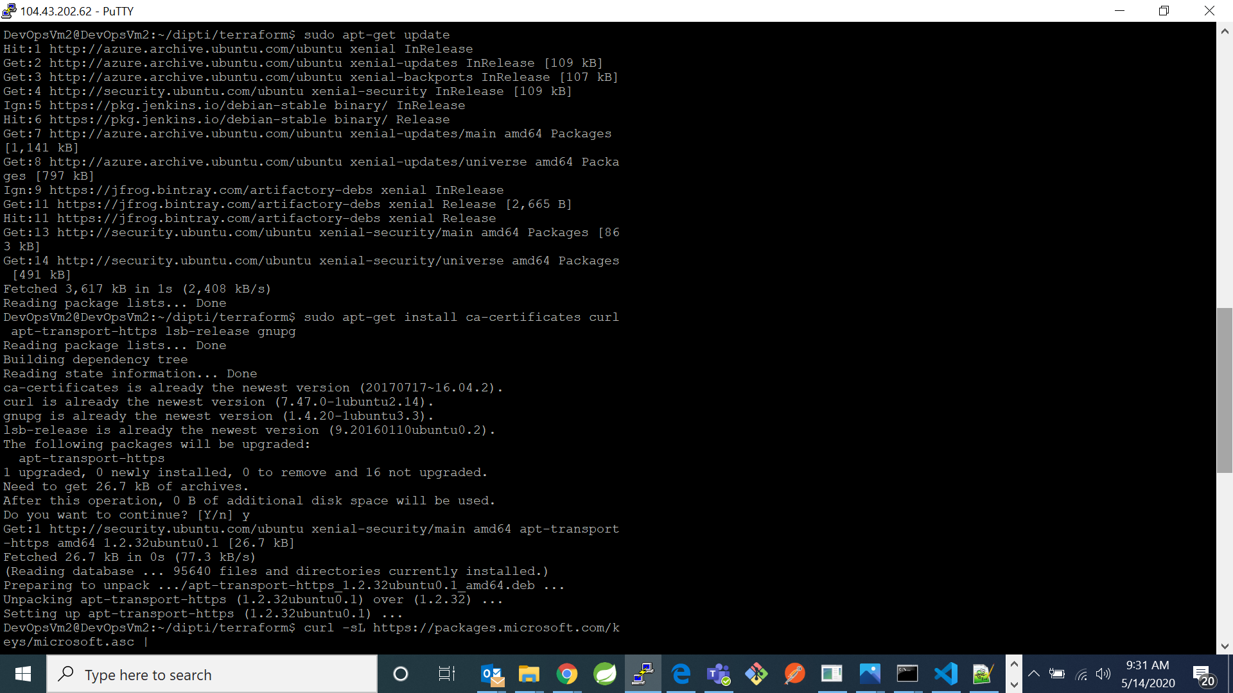



1. Now type command “curl -sL https://packages.microsoft.com/keys/microsoft.asc | gpg --dearmor | sudo tee /etc/apt/trusted.gpg.d/microsoft.asc.gpg >/dev/null”. It will download and install the Microsoft signing key.

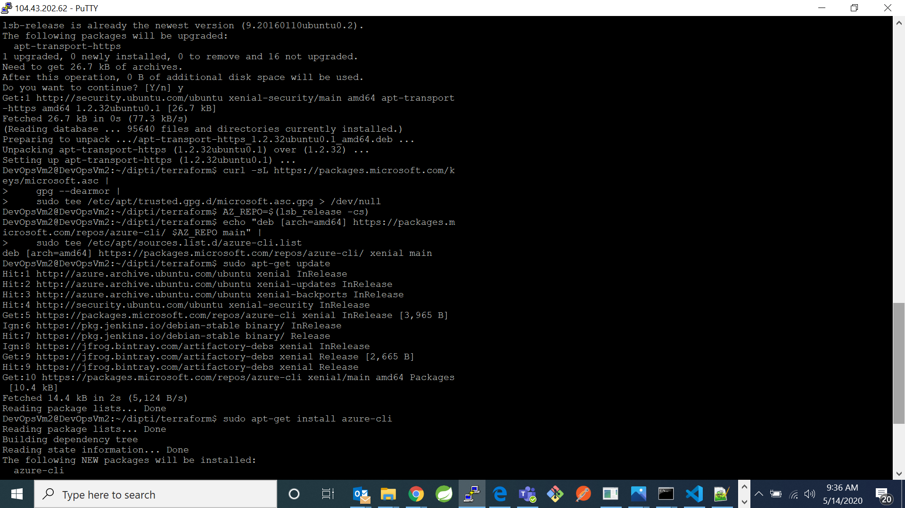

1. Now type commands: “AZ_REPO=$(lsb_release -cs)”

“ echo "deb [arch=amd64] <https://packages.microsoft.com/repos/azure->

cli/ $AZ_REPO main" | sudo tee /etc/apt/sources.list.d/azure-

cli.list”. It will add the azure cli software repository.



1. Now type command “sudo apt-get install azure-cli”

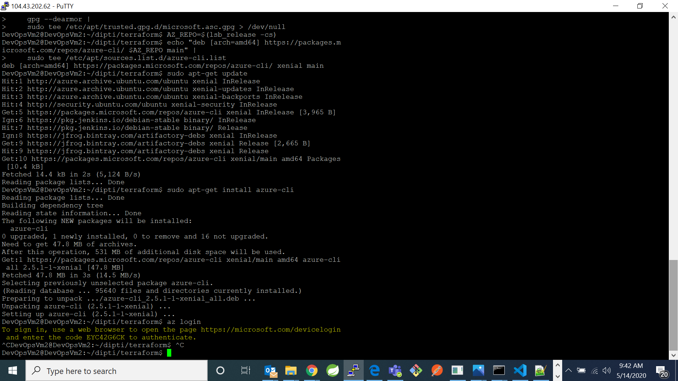

1. Now type “az login” and copy the link generated and the code by the command

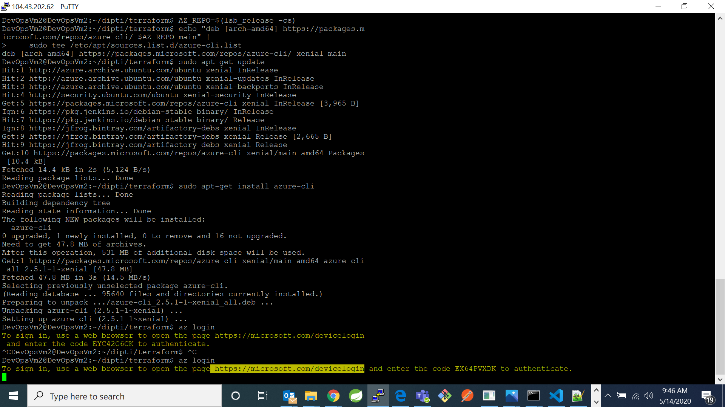

1. Go to browser and copy the url. It will open a page which will be asking to enter a code. Copy the code generated by the “az login” command here and click next. It will take you to choose an account.

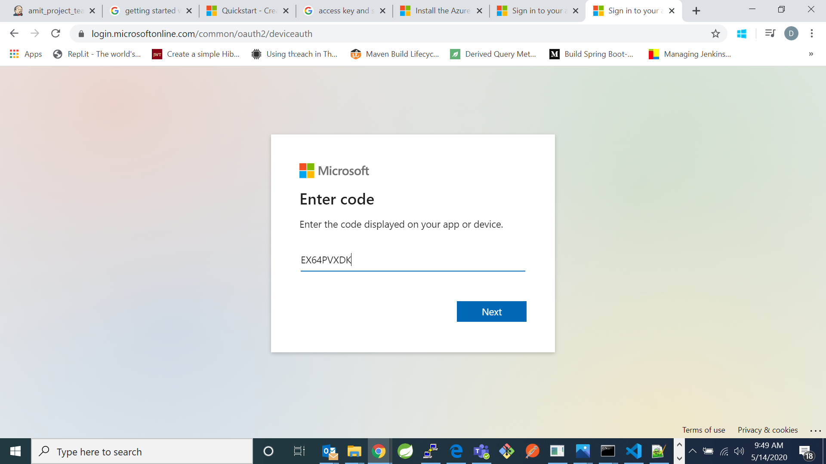

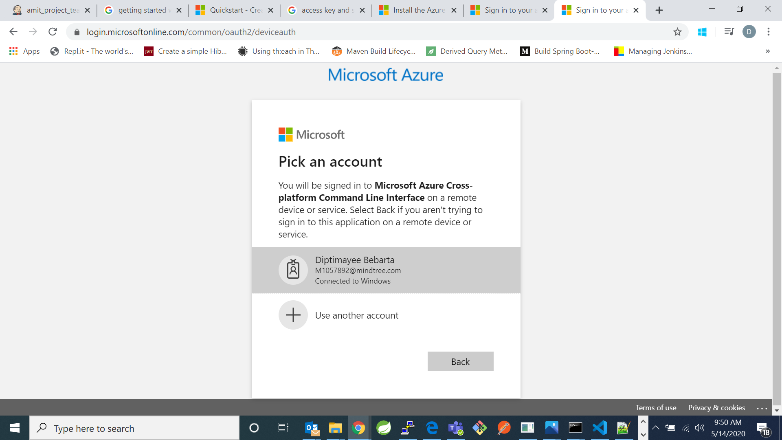

1. After signing in it will show the message:

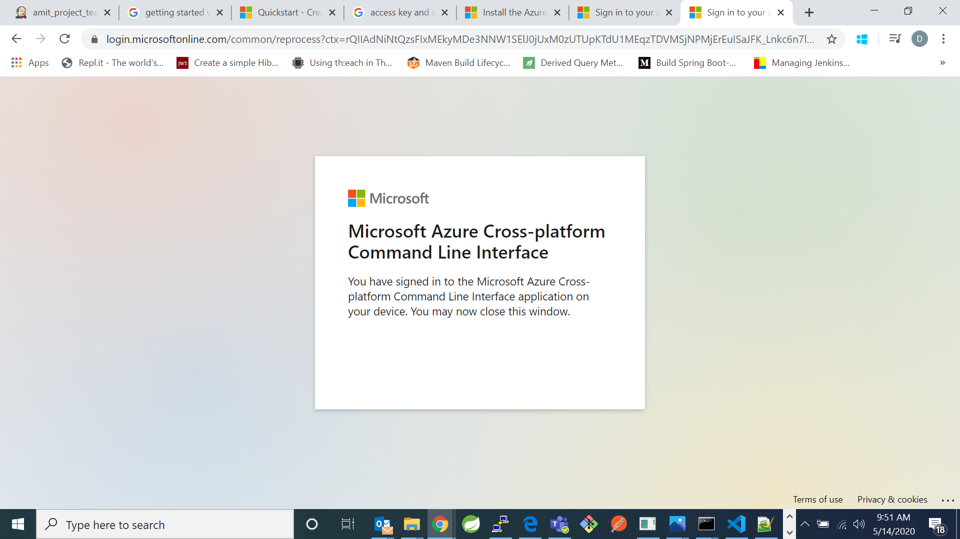

1. Now go back to your linux cli, it will show the details of your account and session: 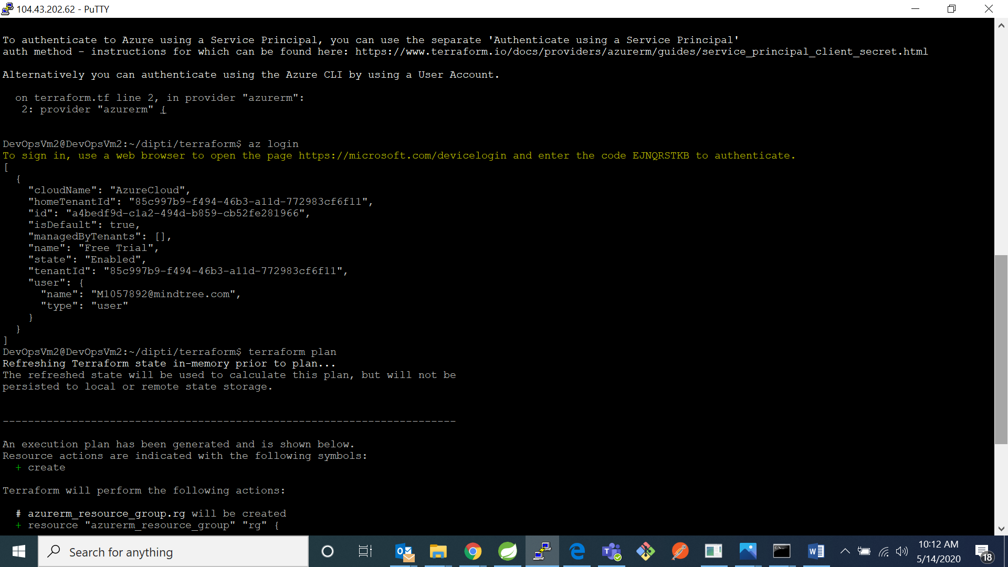
2. Configuration in terraform
3. Create your own directory for terraform using command “mkdir terraform”

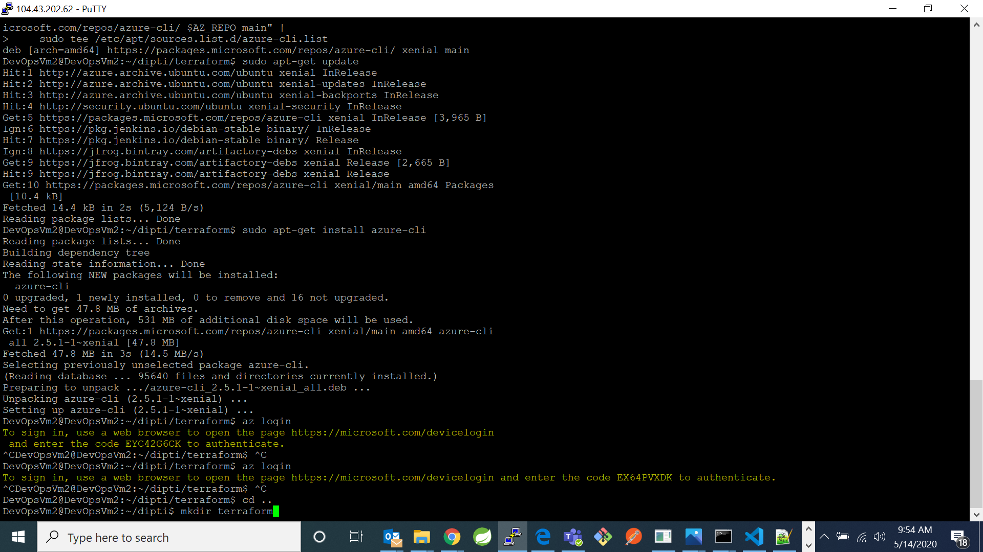

1. Now go the directory

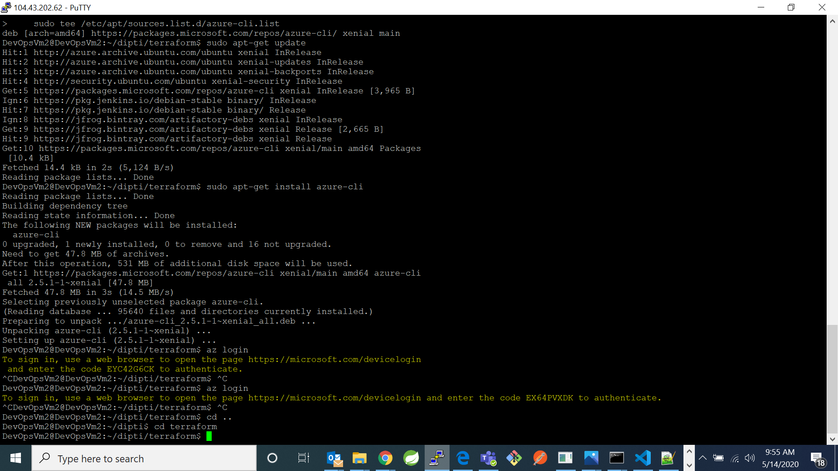

1. Now type command “sudo nano terraform.tf”. And write the following code in that file:

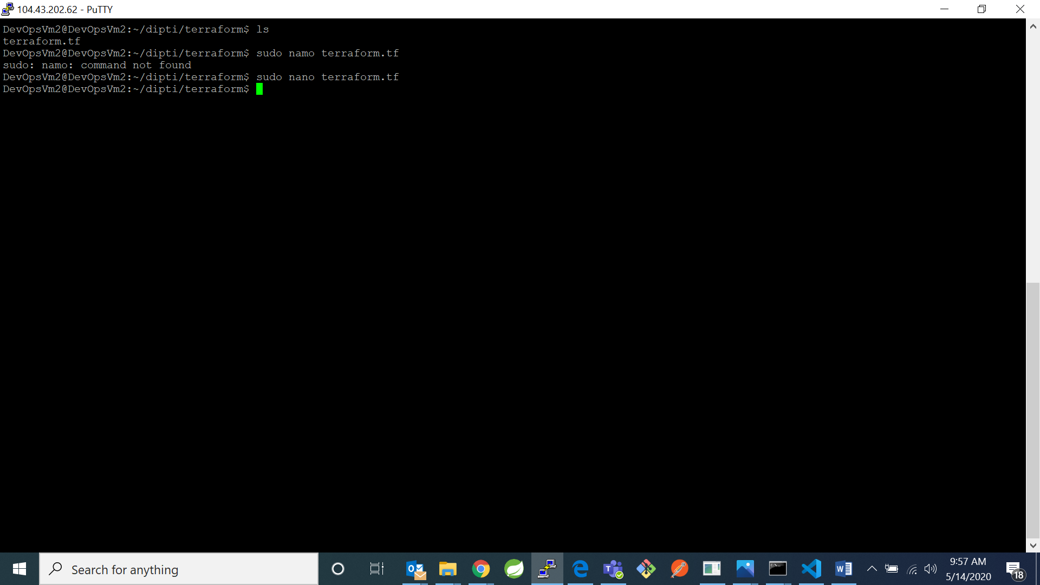

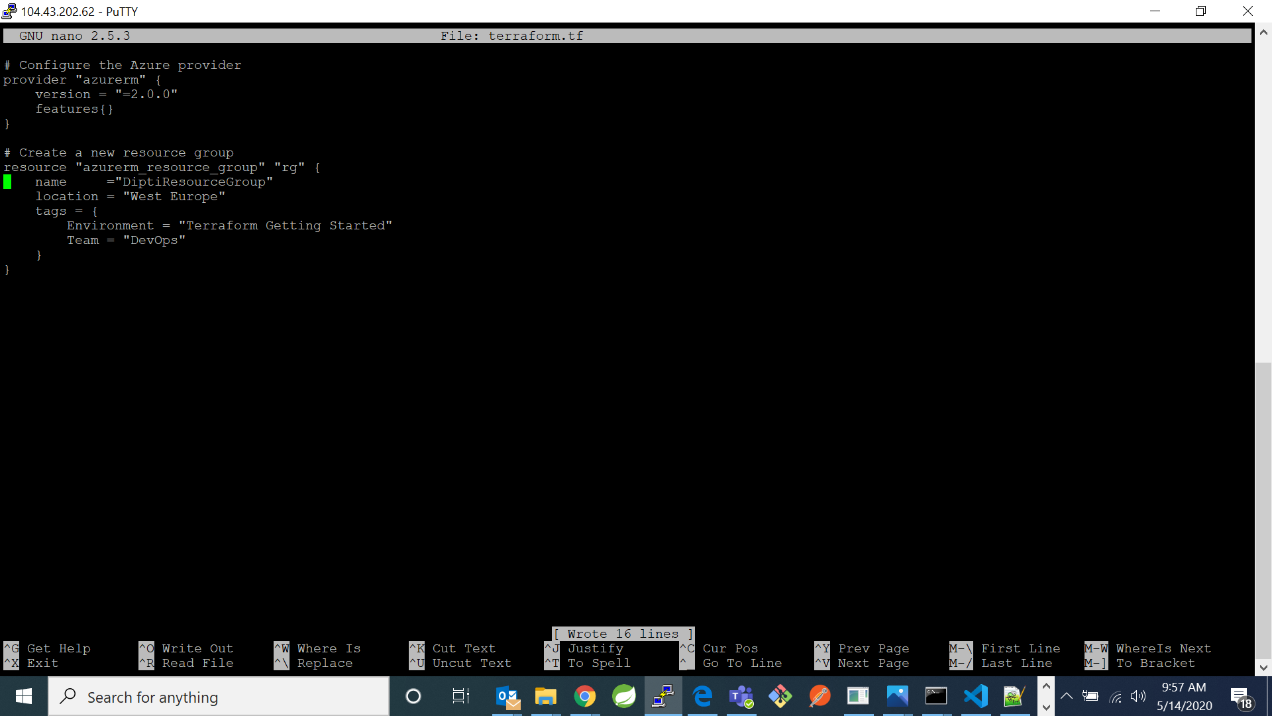

1. Now type command “terraform init”- command will automatically download and install any provider binaries required by the providers specified in the configuration.

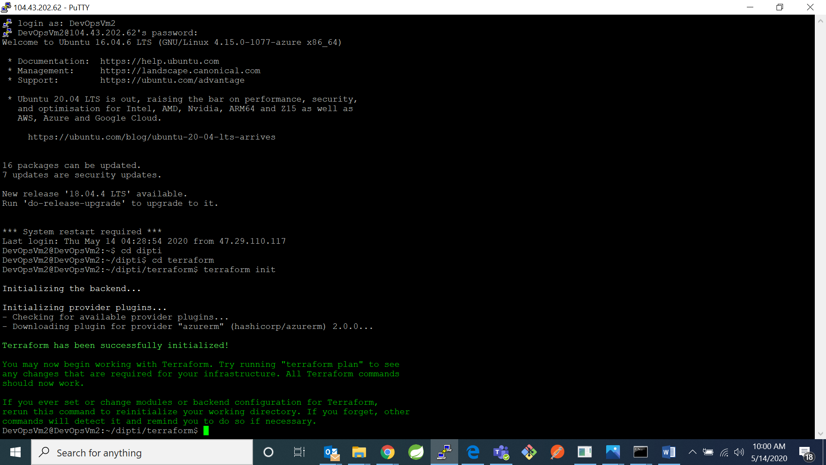

1. Now type command “terraform plan” -specifies what actions Terraform will take to achieve the desired state defined in the configuration, and the order in which the actions occur

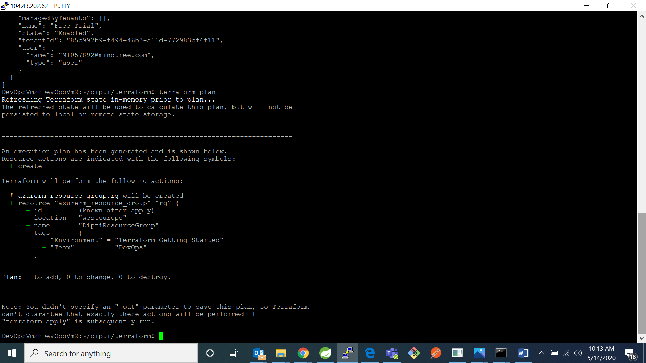

1. Now type command “terraform apply”- it will apply the changes to the configurations. When asking for enter a value enter yes.

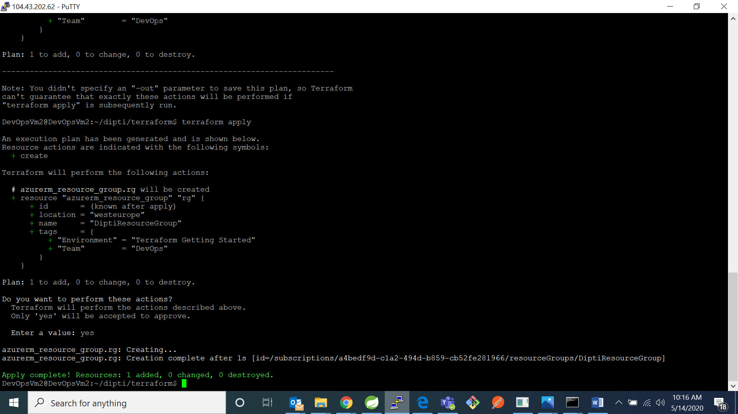

1. Now you can check the configuration made by you in the command line by typing the command “terraform show”

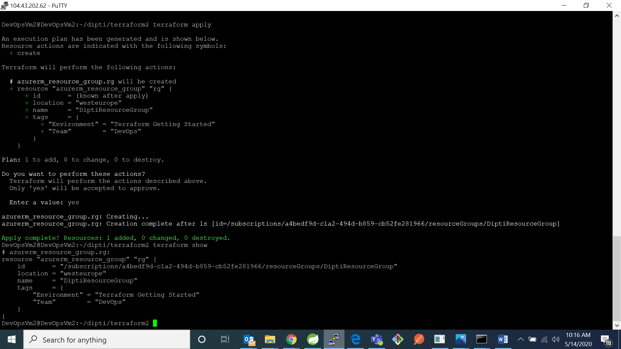

1. Now go to your azure portal in that go to resources group and check for your resource group is created or not



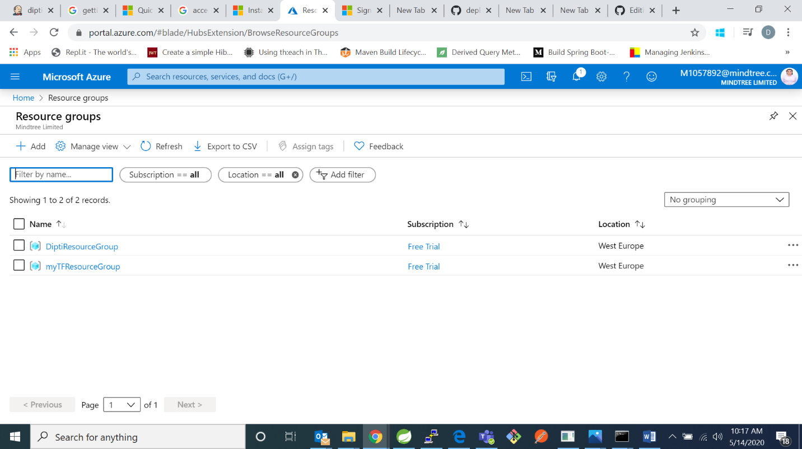

My resource group named “DiptiResourceGroup”was successfully created.